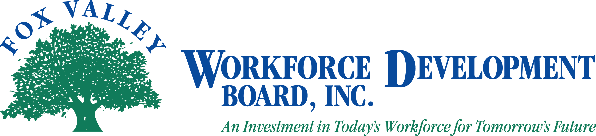

Meeting Notice

Fox Valley Workforce Development Board
Youth Council Committee

1:00 p.m.

Wednesday, September 5, 2012

The Fox Valley Workforce Development Board Youth Council will hold a meeting on Wednesday, September 5, 2012.

Agenda

- Call to Order
- Introductions and Welcome New Members
- Approval of minutes from April 19, 2012
- Current WIA Youth Program Providers and Performance Report
- K-12 Activities Update – Reality Stores, Career Fairs, FOCUS
- H1B Grant – Jill Valdez
- Outagamie County Update
- Subcontractor update - Workforce Economics, Inc.
- Next meeting dates
- Other business
- Adjourn

Please note: If you wish to attend the meeting, please visit the Administrative Office at 1401 McMahon Drive, Neenah. If you need special accommodations please call 920-720-5600.

