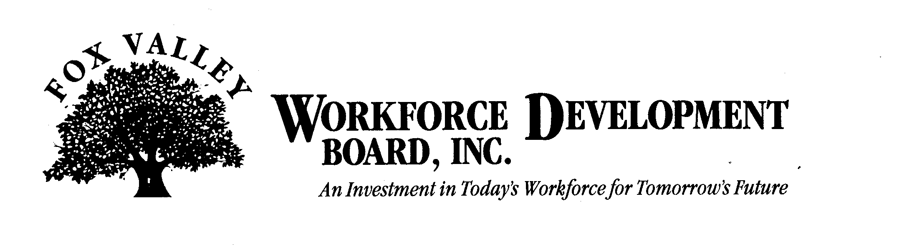

Meeting Notice

Fox Valley Workforce Development Board
Youth Council Committee

1:00 p.m.

Thursday, June 2, 2011

The Fox Valley Workforce Development Board Youth Council will hold a meeting on Thursday, June 2, 2011 in the Board offices at 1401 McMahon Drive, Neenah.

Agenda

- Call to Order
- Introductions
- Approval of minutes from December 6, 2010
- PY 11 Program Delivery
- Move to Closed Session as per State Statute 19.85(1)(e) for Competitive Bid Process
a.) PY 11 Youth RFP Submissions
b.) Proposer Presentations
c.) Committee Discussion
- Return to Open Session as per State Statute 19.85(1)(e) for Competitive Bid Process
- Approval of Actions Discussed in Closed Session
- Awarding of PY 11 Youth Contract
- Legislative Update
- Funding Update
- Next Steps
- Adjournment

