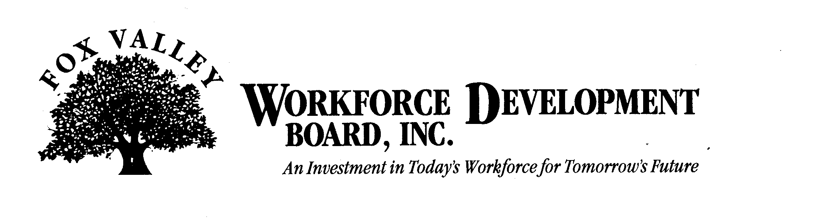

Meeting Notice

Fox Valley Workforce Development Board
Youth Council Committee

1:00 p.m.

Monday, December 6th, 2010

The Fox Valley Workforce Development Board Youth Council will hold a meeting on Monday, December 6th, 2010 in the Board offices at 1401 McMahon Drive, Neenah.

Agenda

- Call to Order
- Introductions
- Approval of minutes from June 8, 2010
- K-12 Activities Update
a.) Reality Stores
b.) Career Fairs
c.) Chamber Partnership
- Summer Youth Employment Program Report
- Discuss and Develop Programming
a.) Aging out of Foster Care
b.) Juvenile Offender Population
- WIA Program Performance
- “FOCUS” group on STEM (Science, Technology, Engineering, & Math)
- Other Business
- Adjourn

