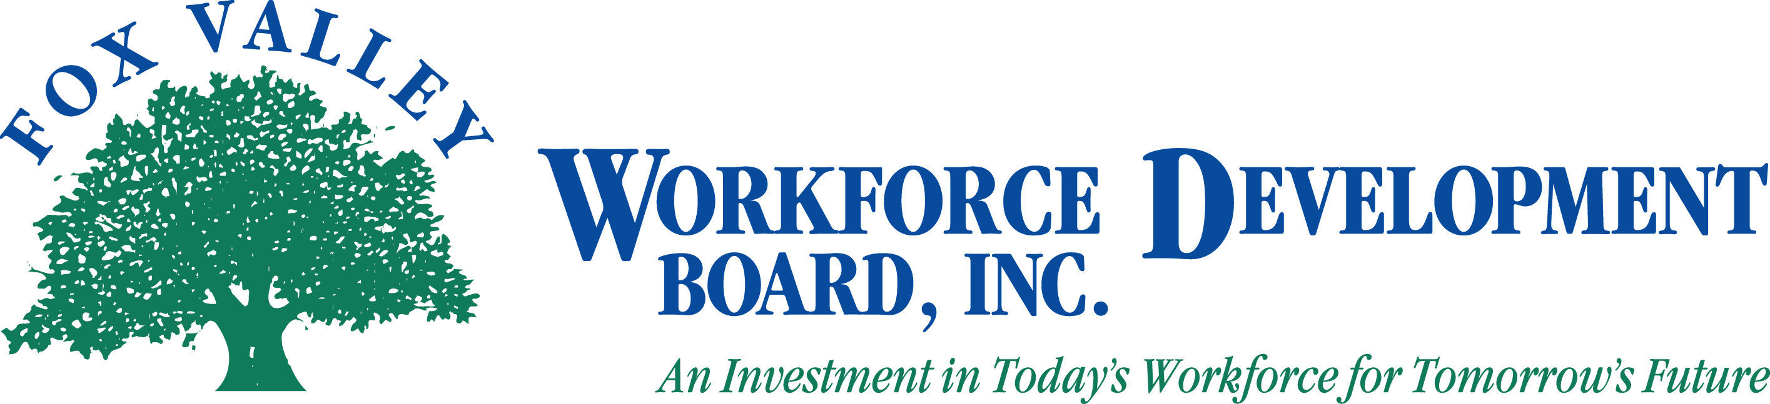

Fox Valley Workforce Development Board, Inc.
February 6, 2012
1:00 p.m.

The Fox Valley Workforce Development Board will hold a meeting on Monday, February 6, 2012 at 1:00 p.m.

- Call to Order
- Roll Call
- Approval of Minutes from January 9, 2012 (Action Item)
- Consent Agenda (Action Item)
- January 17, 2012 Executive Committee Meeting
- January 25, 2012 LEO & Executive Committee Joint Meeting
- PY10 Audit
- Administrative Office Options
- LEO and Board Joint Agreement (Action Item)
- PY11 Budget Update
- New Grants
- One Stop System
- Oshkosh, Green Lake, Waupaca, Waushara
- Update on PY11-Q1 Performance
- Dislocated Worker Activity
- Move to Closed Session as per State Statute 19.85(1)(c) for Personnel (Action Item)
- Return to Open Session as per State Statute 19.85(1)(c) for Personnel (Action Item)
- Approval of Actions Discussed in Closed Session
- National Association of Workforce Development Professionals Conference
- Announcements
- Adjournment

Please note: If you wish to attend the meeting, please visit the Administrative Office at 1401 McMahon Drive, Neenah. During the closed session portion of the meeting, the public will be asked to leave the room. If you need special accommodations please call 920-720-5600.

