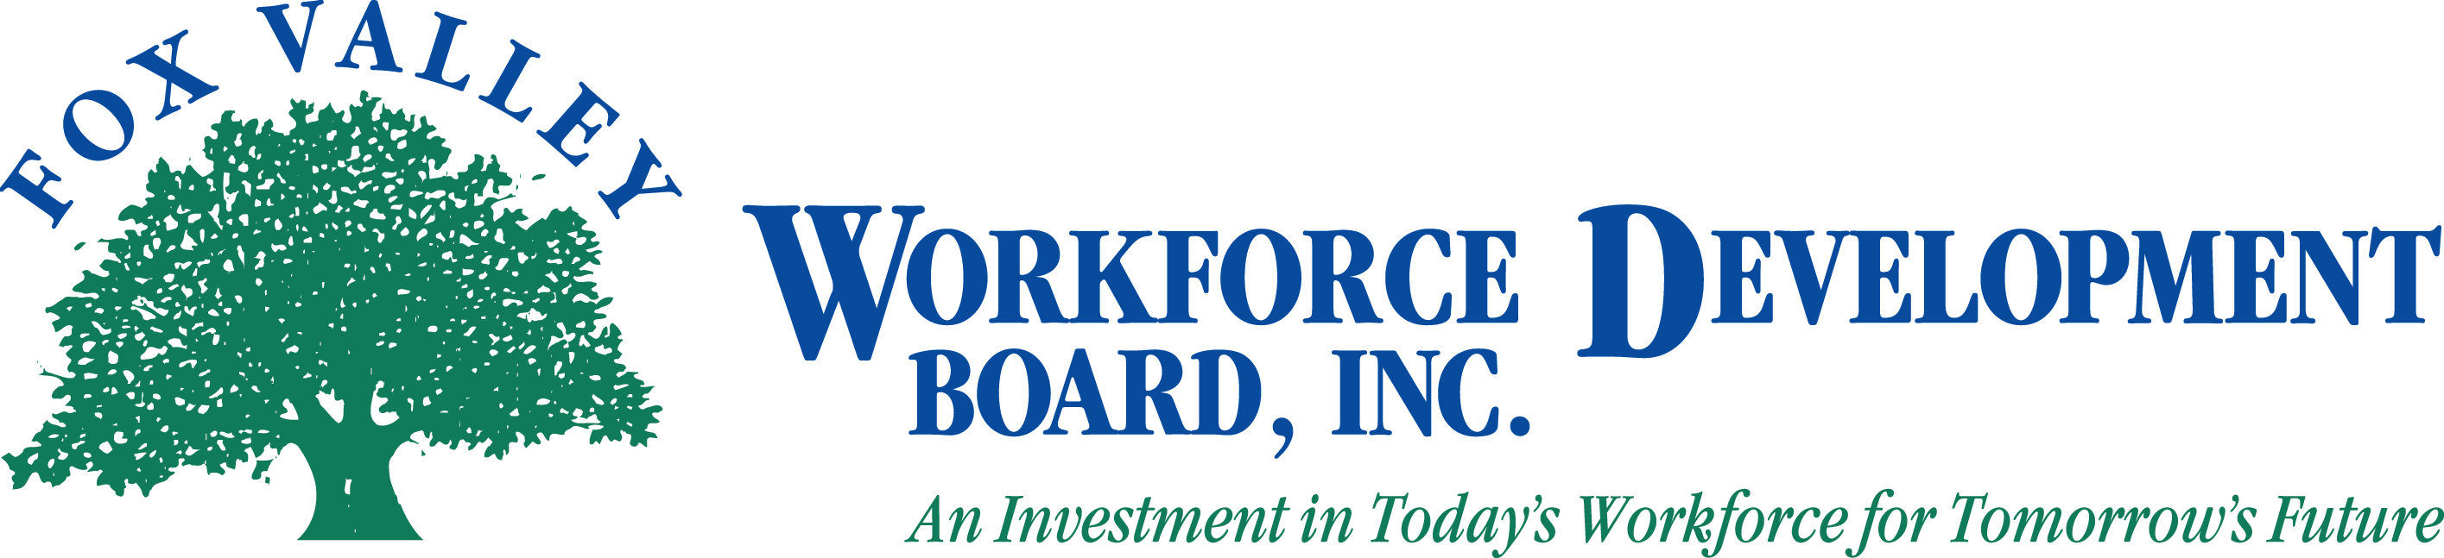

Fox Valley Workforce Development Board, Inc.
Local Elected Official Meeting
May 30, 2012

The Fox Valley Workforce Development Board Local Elected Officials (LEO) will hold a meeting on Wednesday, May 30, 2012. Time: 10:00 AM

- Call to Order
- Roll Call
- Approval of Minutes from November 16, 2011 (Action Item)
- PY12 Draft Budget (Action Item)
- Board Membership Nomination/Approval and Matrix (Action Item)
- Follow-on Consortium and Joint Agreement language additions as suggested by DWD (Action Item)
- Adjournment

Please note: If you wish to attend the meeting, please visit the Administrative Office at 1401 McMahon Drive, Neenah. If you need special accommodations please call 920-720-5600.

