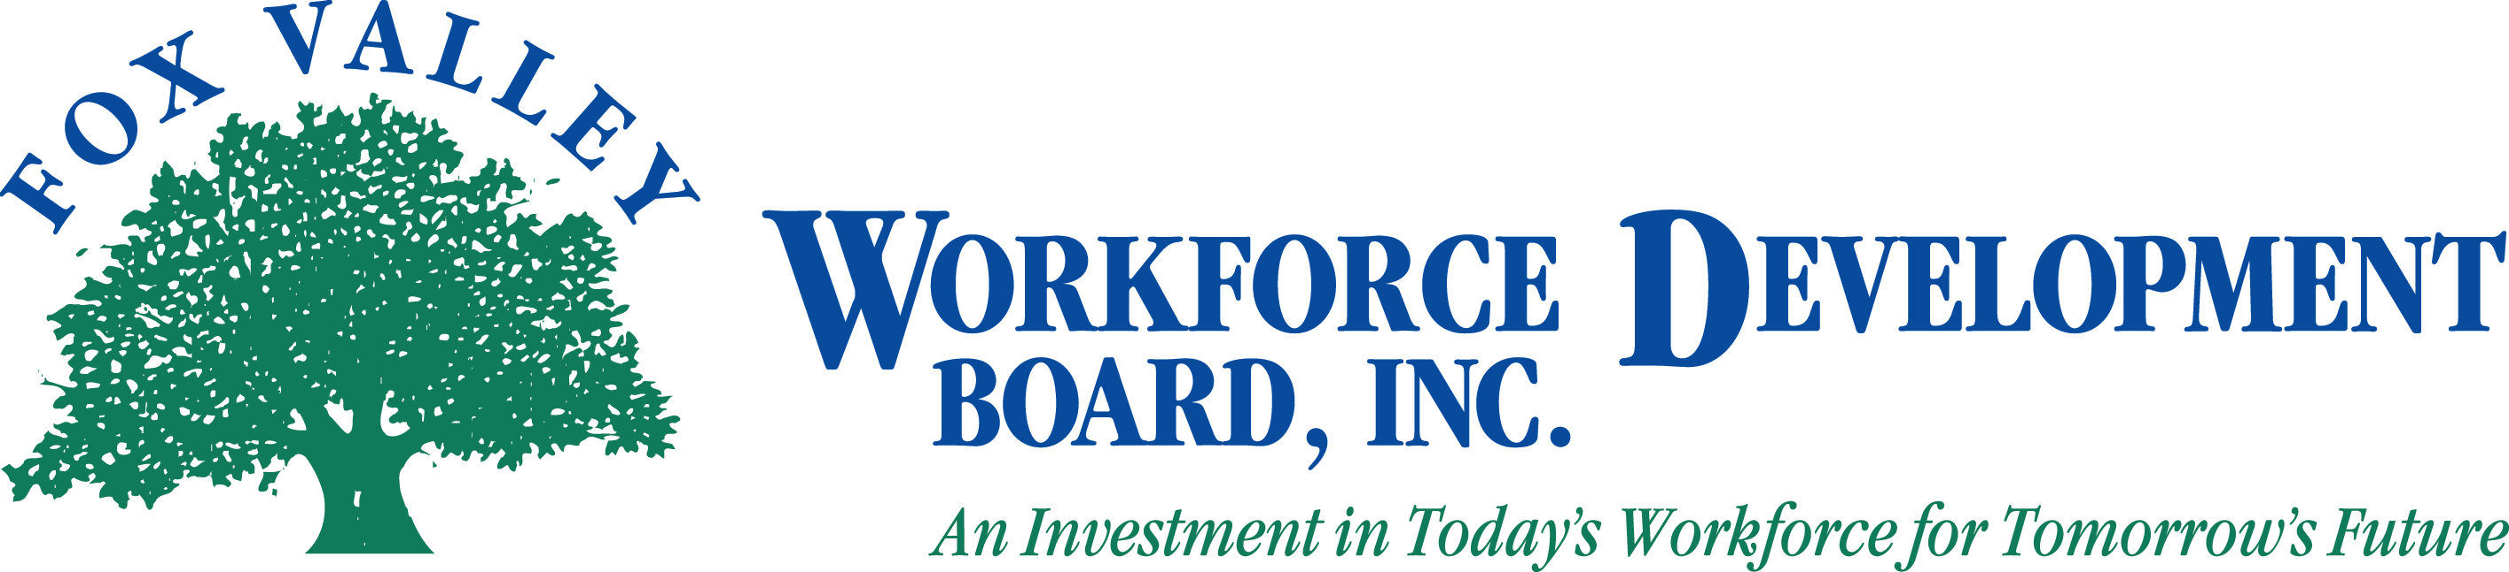

Fox Valley Workforce Development Board, Inc.
Local Elected Officials Meeting

Wednesday, November 16, 2011
1:00 p.m.

The Fox Valley Workforce Development Board Local Elected Officials Consortium will hold a meeting on Wednesday, November 16, 2011 at 1:00 p.m.

- Call to Order
- Roll Call
- Approval of Minutes from October 17, 2011 (Action Item)
- LEO Consortium Agreement and LEO-WDB Joint Agreement
- Job-Centers
- Data
- Oshkosh Area WDC Location
- Fox Cities WDC Location
- Fond du Lac JCC Location
- PY11 WIA Plan
- DWD and DOL Updates
- PY11 First Quarter Budget Expenditures
- Announcements
- Adjournment

Please note: If you wish to attend the meeting, please visit the Administrative Office at 1401 McMahon Drive, Neenah.

