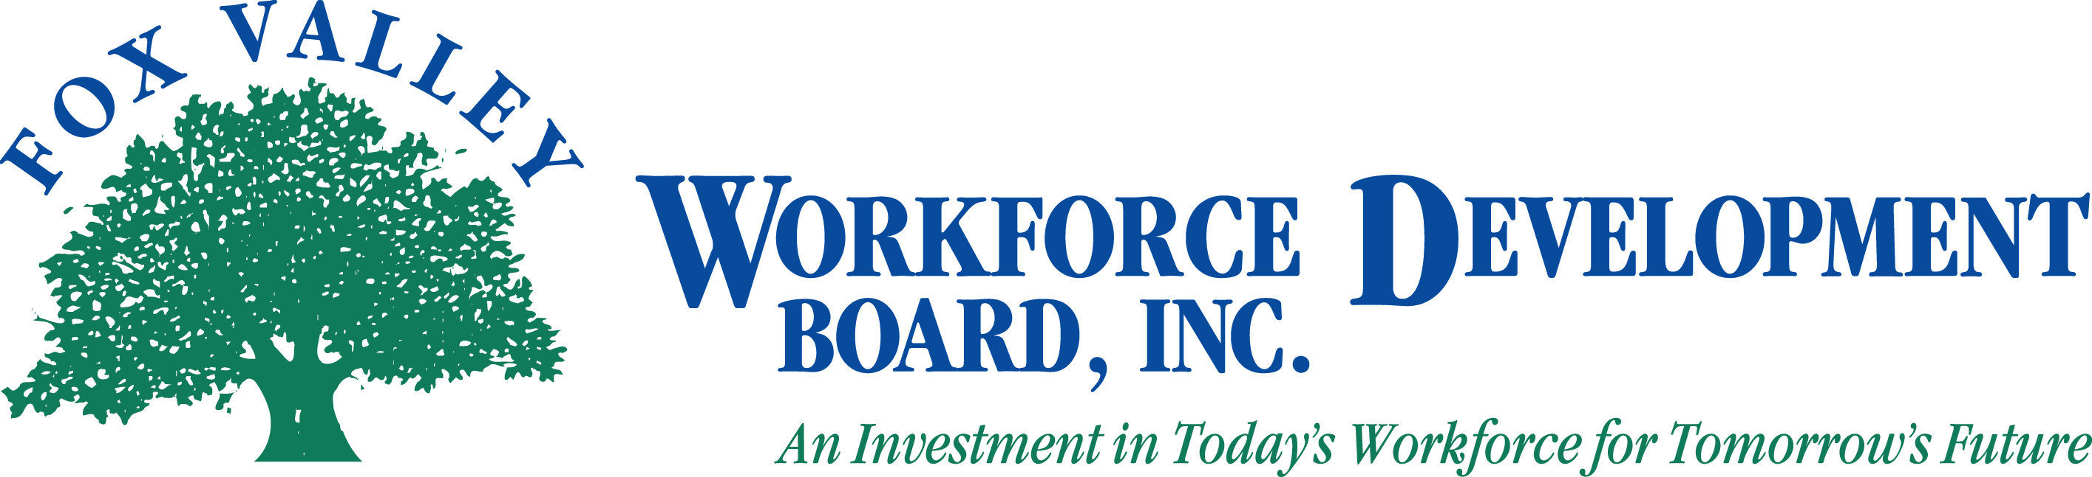
AGENDA
The Fox Valley Workforce Development Board Local Elected Officials and
Executive Committee, will hold a Special Joint Meeting on
Wednesday, February 27, 2013 at 8:30 AM.

- Call to Order
- Roll Call
- Approval of Minutes from
  - Joint LEO / Executive Committee 2012-12-03 (Action Item)
  - LEO 2012-05-30 (Action Item)
  - Executive Committee 2012-05-11 (Action Item)

- Move to Closed Session as per State Statute 19.85(1)(i) for Development of Response to Financial Matter (Action Item)

- Return to Open Session as per State Statute 19.85(1)(i) for Development of Response to Financial Matter (Action Item)

- Approval of Actions Discussed in Closed Session (Action Item)
- Approval of Joint Agreement by LEOs (Action Item)
- Executive Committee to authorize Ad-Hoc committees (Action Item)

- Abbreviated Financial Update
  - PY11 Tax Return
  - PY13 Budget Process
  - Sequestration Contingency Update
  - Oshkosh Corp Update

- Board of Directors Appointment Review / CLEO Validation (Action Item)

- Adjournment
Please note: If you wish to attend the meeting, please visit the Administrative Office at 1401 McMahon Drive, Neenah. If you need special accommodations, please call 920-720-5600.

