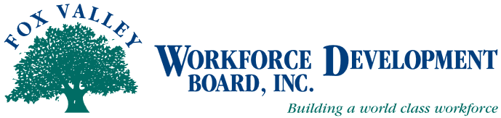

Fox Valley Workforce Development Board
Finance Committee Agenda

The Finance Committee of the Fox Valley Workforce Development Board will hold a meeting on Monday, November 10, 2014 @ 2:30 PM at the Oshkosh Job Center.

- Call to Order
- Approval of 8/11/14 minutes (Action Item)

Old Business
- DOL Audit Update
- PY13 Audit Status
- PY14 Audit RFP

New Business
- Cost Allocation Plan – Job Centers (Action Item)
- Revised Financial Statement Format

Quarterly Review and Approvals (Action Items)
- Credit Card Statements
- Check Registry – Checks Over $5,000
- Review Board Financial Reports To-Date

- Future Meeting Reminders:
- Monday, February 9, 2015, 2:30 PM, Oshkosh Job Center
- Monday, May 11, 2015, 2:30 PM, Oshkosh Job Center

- Adjournment

Meeting Location:
Oshkosh Job Center
219 East Washington Street
Oshkosh, WI 54901
920-232-6273

For additional information, if you require assistance to attend the meeting, in accessing meeting materials, or if you need an interpreter, contact Beth Reinke at FVWDB, 1401 McMahon Road, Suite 200, Neenah, WI 54956, breinke@fvwdb.com, 920-720-5600

