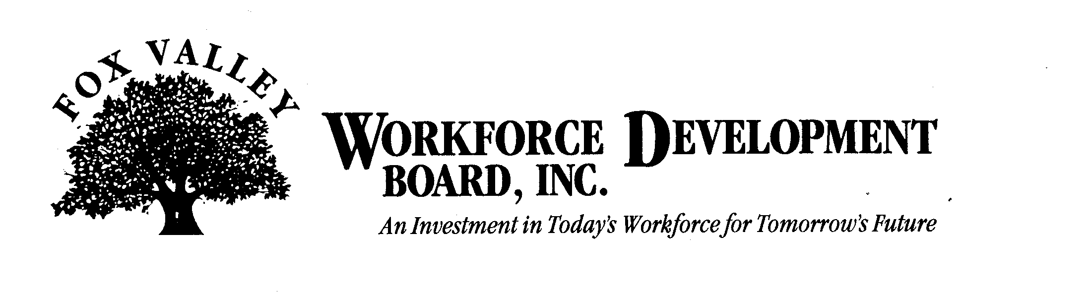

Fox Valley Workforce Development Board, Inc.

Economic Development Committee Meeting

Thursday, October 13, 2011 at 1 p.m.

The Fox Valley Workforce Development Board Economic Development Committee will hold a meeting on Thursday, October 13th, 2011 at 1 p.m. This meeting will be held at the FVWDB offices, 1401 McMahon Drive, Neenah.

AGENDA

- Call to Order
- Approval of Minutes from May 24, 2011
- PY11 Local WIA Plan
- Industry Sector Funnel
- Alignment of Services
- Economic Gardening
- Dislocated Worker Update and Programming
- Entrepreneur Programs
- Adjournment

