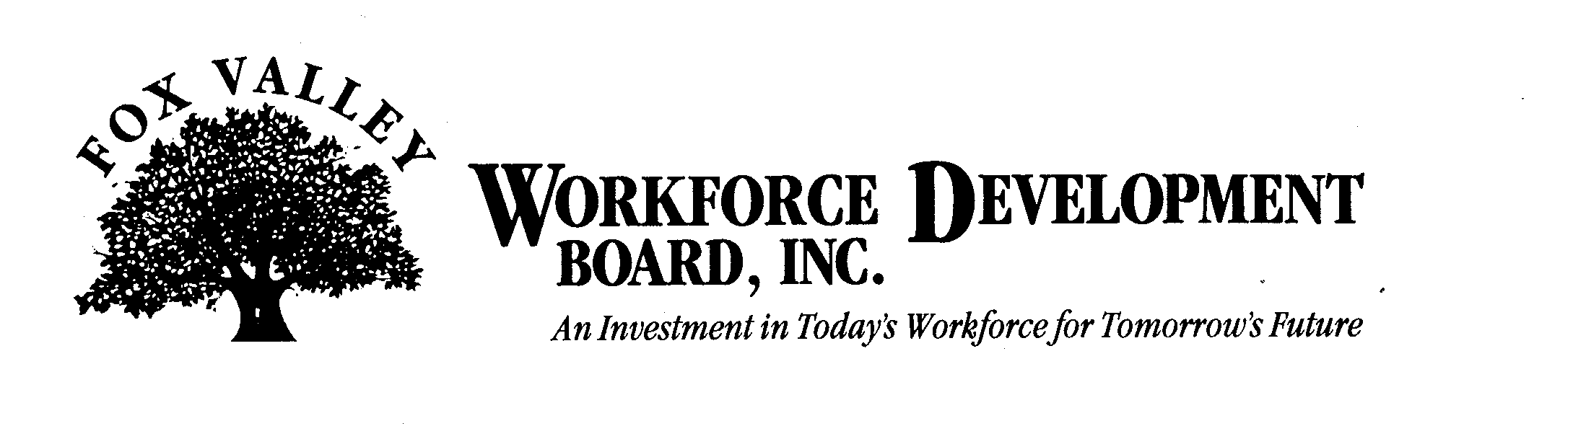

Economic Development Committee Meeting

Tuesday, May 24, 2011
9:00 a.m.

The FVWDB Economic Development Committee will hold a meeting on Tuesday, May 24th, 2011. This meeting will be held at the FVWDB offices, 1401 McMahon Drive, Neenah.

AGENDA

- Call to Order
- Approval of Minutes from March 2, 2011
- Opportunities for PY 11 Economic Development and Workforce Development Partnerships
- DWD and Commerce Direction
- Update on Federal Legislation
- Discussion of Service Delivery System
- Next Steps on the “Ripples from the Zambezi” Book Project
- Update on Job Creations and Dislocations
- Announcements
- Adjournment

