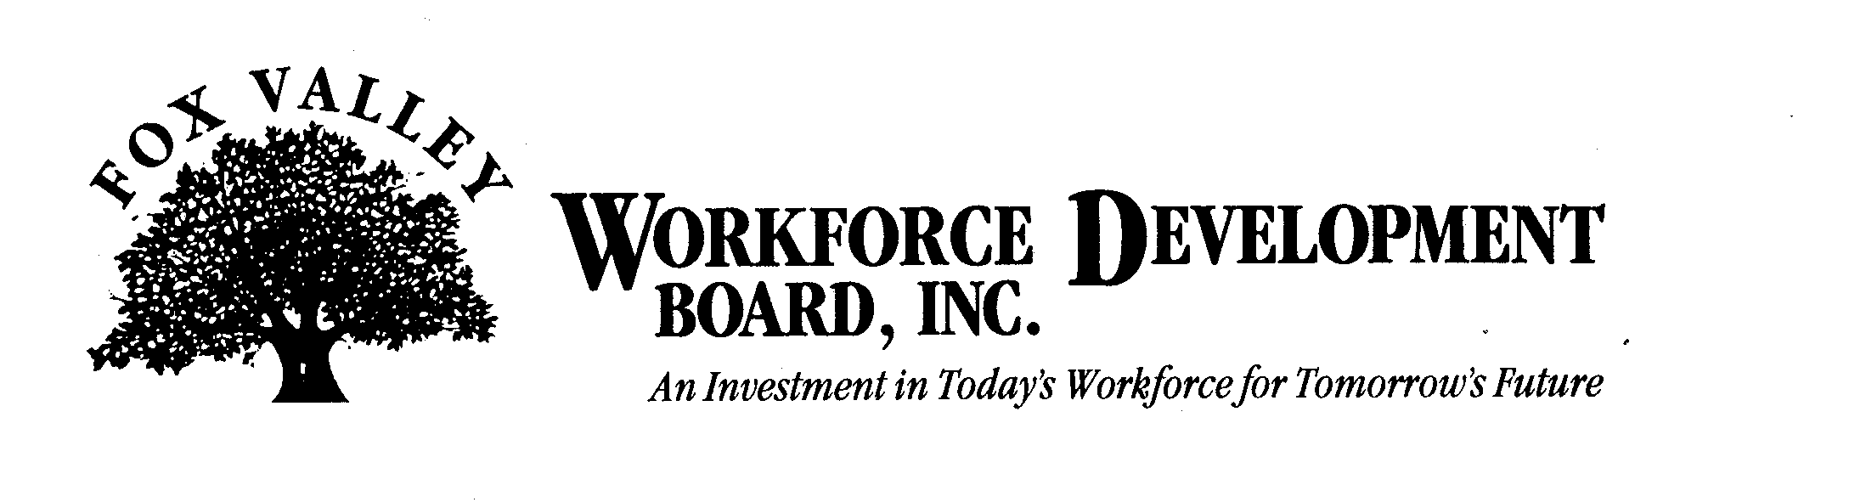

Economic Development Committee Meeting

Tuesday, August 10th, 2010
9:00 a.m.

The FVWDB Economic Development Committee will hold a meeting on Tuesday, August 10, 2010. This meeting will be held at the FVWDB offices, 1401 McMahon Drive, Neenah.

AGENDA

- Call to Order
- Introductions
- Approval of minutes from May 6, 2010
- Dislocated Worker Activity Update
- Discussion on the Wisconsin Competitiveness Study
- Discussion on the Incubator Project
- Other Projects
- Adjournment

