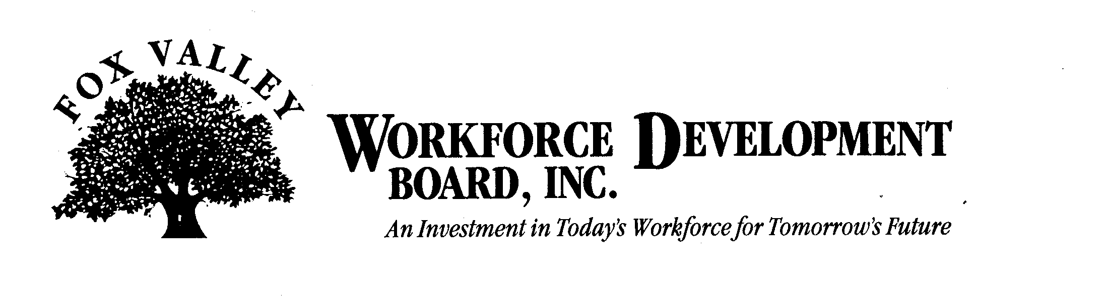

Economic Development Committee Meeting

Thursday, May 6th, 2010
11:00 a.m.

The FVWDB Economic Development Committee will hold a meeting on Thursday, May 6th, 2010. This meeting will be held at the FVWDB offices, 1401 McMahon Drive, Neenah.

AGENDA

- Call to Order
- Introductions
- Approval of minutes from March 2, 2010
- Dislocated Worker Activity Update
- FVWDB Business Services Update
- Development of PY 10 Committee Goals
- Other Business
- Adjournment

