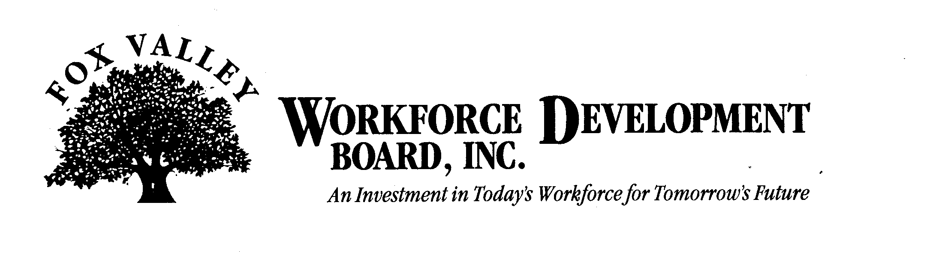

Economic Development Committee Meeting

Tuesday, September 8th
11:00 a.m.

The FVWDB Economic Development Committee will hold a meeting on Tuesday, September 8th. This meeting will be held at the FVWDB offices, 1401 McMahon Drive, Neenah.

AGENDA

- Call to Order
- Introductions
- Approval of minutes from May 14, 2009
- Dislocated Worker Activity Update
- Recovery Zone Bonds
- Green Jobs and Workforce Development
- American Reinvestment & Recovery Act (ARRA) Update
- Identification of New Industry Sectors
- Development of Small Business Support Network
- Other Business
- Adjournment

