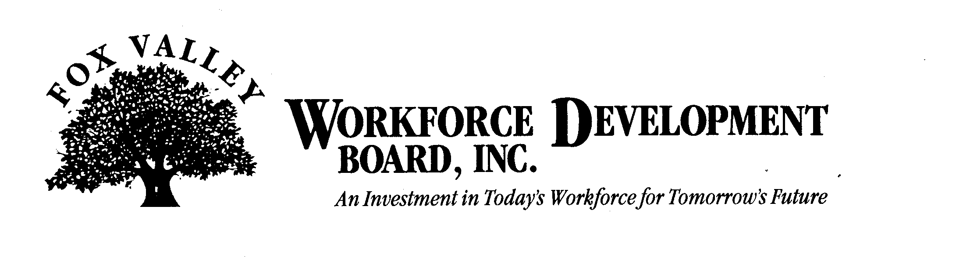

Economic Development Committee Meeting

Thursday, May 14, 2009
9:00 a.m.

The FVWDB Economic Development Committee will hold a meeting on Thursday, May 14th, 2009. This meeting will be held at the FVWDB offices, 1401 McMahon Drive, Neenah.

AGENDA

- Call to Order
- Introductions
- Approval of minutes from January 29th, 2009
- Business Plan Competition Update
- Dislocated Worker Activity Update
- American Reinvestment & Recovery Act (ARRA) Update
- Discussion
a) Creation of New Job Opportunities
b) Incumbent Worker Training
c) Individuals who have lost Businesses/Need Support
- Other Business
- Adjournment

